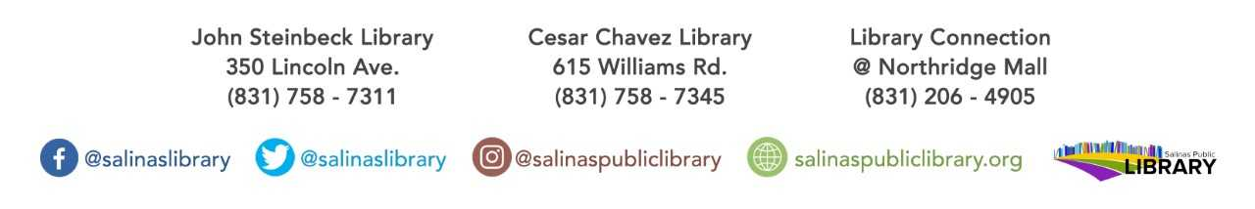

The Teen Collab Group’s book club title:

**Brave New World by Aldous Huxley**

Must be in 9th-12th grade to participate. Books available at

Cesar Chavez Library while supplies last!

Book discussion will be held at Cesar Chavez Library

On October 3rd at 4pm.

teen book club

