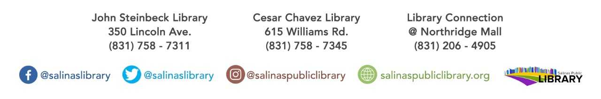

The Teen Collab Group’s Summer book club title:

**Everything I Never Told You by Celeste Ng**

Must be in 9th-12th grade to participate. Books available at

Cesar Chavez Library while supplies last!

Book discussion will be held at Cesar Chavez Library

On August 1st @ 2.

**teen** book club

