|  |
| --- |
| Looking for a **fun** way to earn community service hours?  **Teen**  **Collab**  **Group**  Join us at the  Cesar Chavez Library  3rd Thursdays  of each month  4:00-6:00p.m. |

**TCG Overall Goals: To participate in simple community service projects and organize library programs for teens**

**TCG HIGHLIGHTS:**

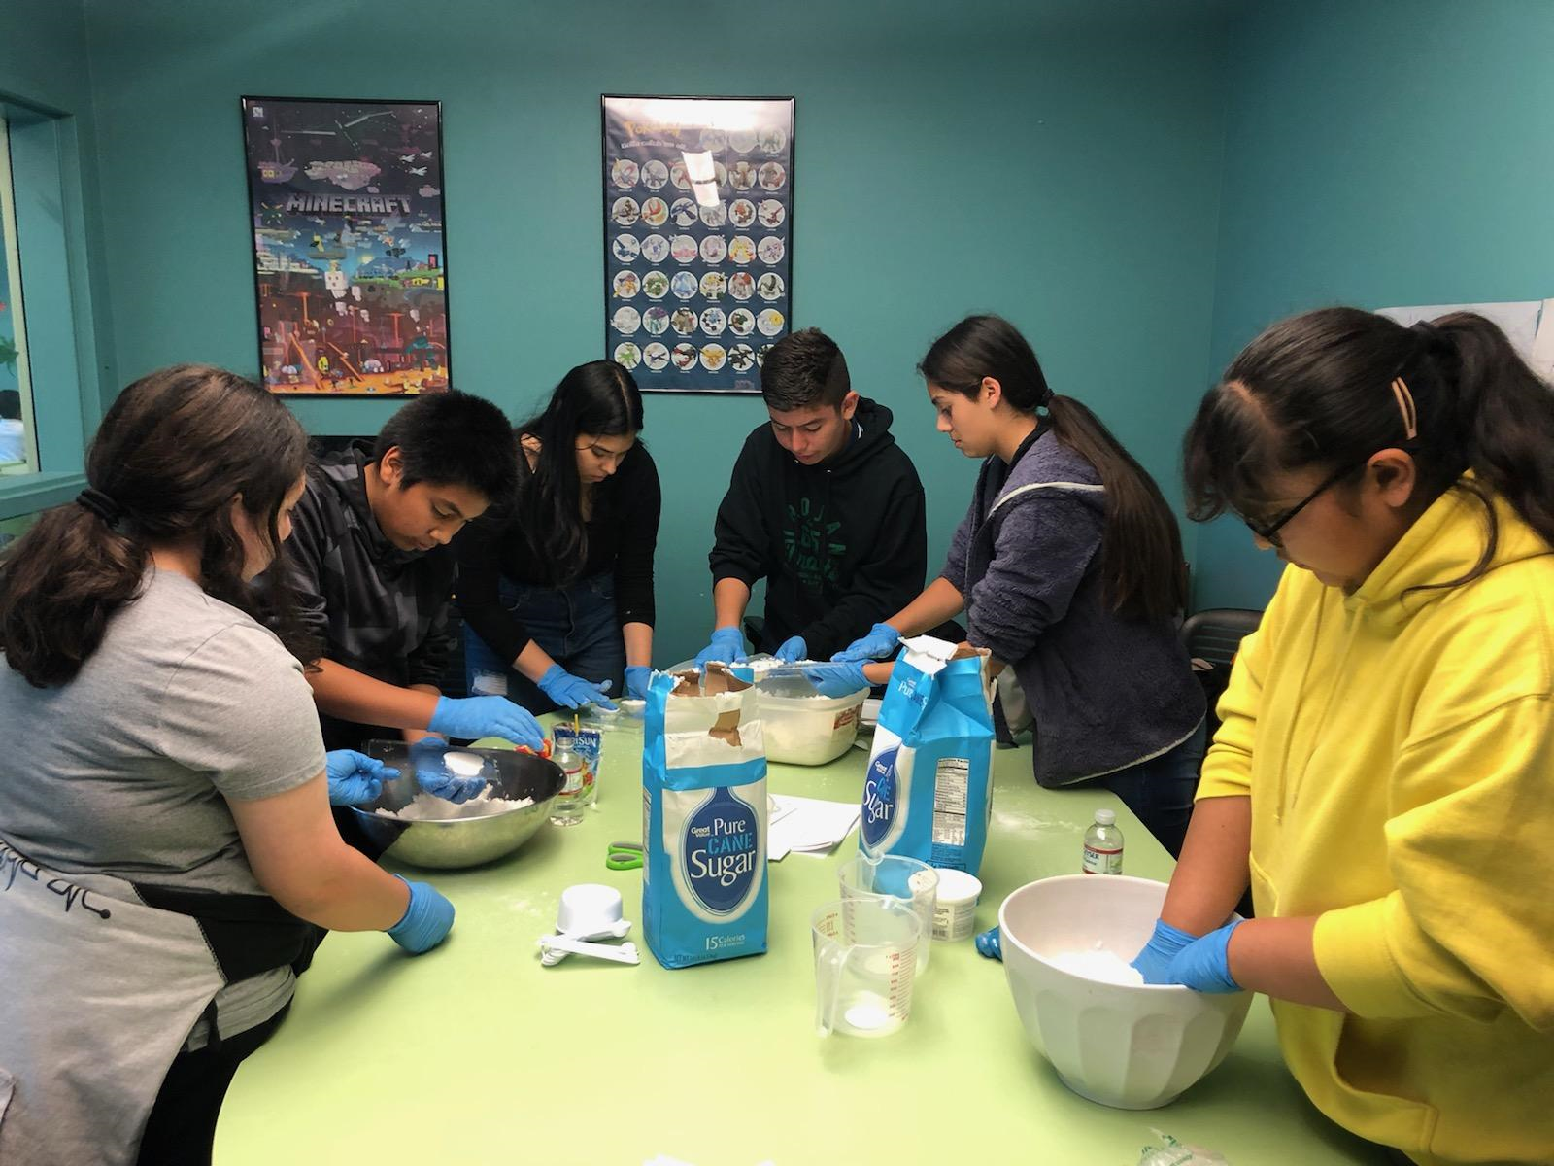 **Making Sugar Skulls**



**TCG Book Club New Book Reading:**

**The Perks of Being Flower**