Tech for Teens/APP Development
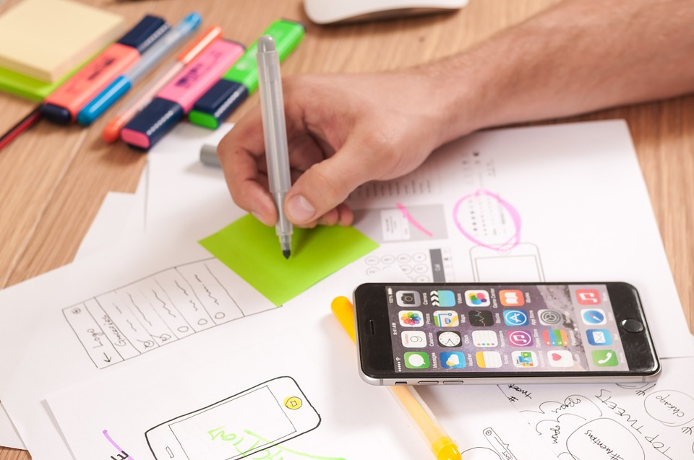 | Cesar Chavez Library  615 Williams Road  Salinas, CA 93905  831-758-7345  Saturdays  August 25 –  September 29  3 – 5:30 p.m.
Libraries Are for Teens!

Join us for Phase 3 of the App Development program. We are now through the Design and Development Phases and ready for Testing and Refining. The Evolution of this app will result in a modern way to increase teen usage at the Salinas Public Libraries Sign up here: https://goo.gl/forms/hMeV3p4r1VW58XmJ3
www.salinaspubliclibrary.org

