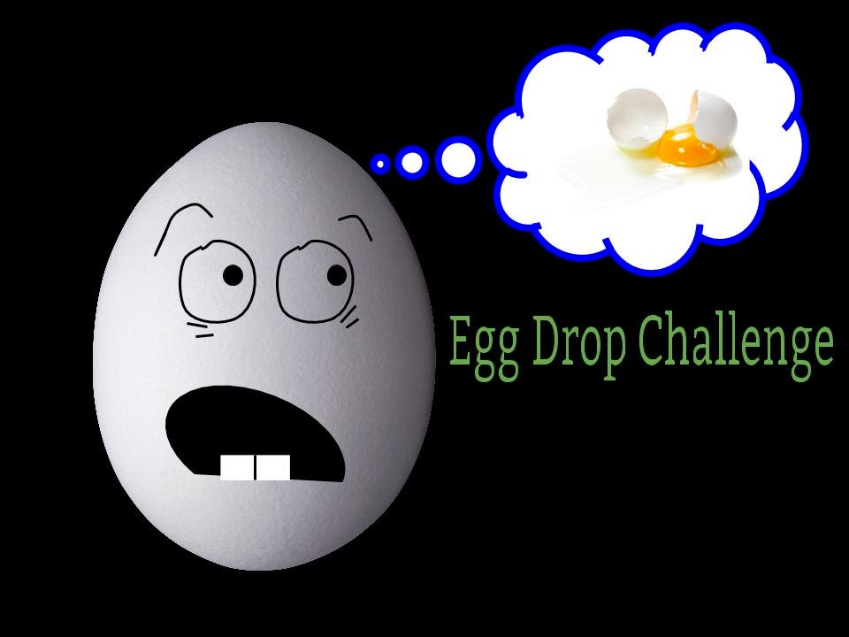

# Cesar Chavez Library (615 Williams Rd, Salinas)

# Saturday, December 7, 2019 12-2:00pm

Please come for a fun afternoon of STEM activities at your library.

4-H youth will lead hands on STEM activities that introduce physics, computer science, and the scientific method in a fun and exciting way. Community youth, ages 8 and up, are encouraged to attend. Activities will be presented by the Buena Vista 4-H STEM Team youth members.

RSVP’s are strongly encouraged. Limited to 40. To RSVP by

December 1, sign up at the library or email [Buenavista4h@gmail.com](mailto:Buenavista4h@gmail.com). Questions, call Chris at (831) 758-7015.

R(831)



It is the policy of the University of California (UC) and the UC Division of Agriculture & Natural Resources not to engage in discrimination against or harassment of any person in any of its programs or activities (Complete nondiscrimination policy statement can be found at <http://ucanr.edu/sites/anrstaff/files/215244.pdf> )

Inquiries regarding ANR’s nondiscrimination policies may be directed to John I. Sims, Affirmative Action Compliance Officer/Title IX Officer, University of California, Agriculture and Natural Resources, 2801 Second Street, Davis, CA 95618, (530) 750-1397.

*Are Double Stuffed Oreos Really Double Stuffed?*

Test your hypothesis

Will your egg survive?

Free Community Youth Science Event Friday, December 7th, 12-2pm

Presented by the Buena Vista 4-H Club STEM team