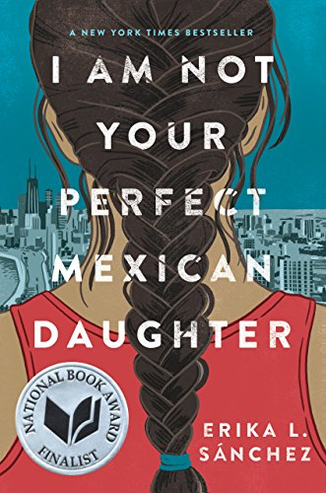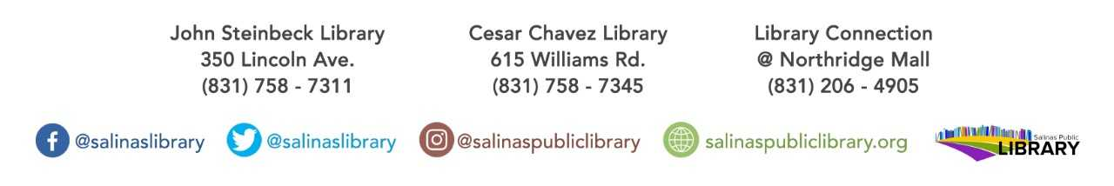

The Teen Collab Group’s Spring book club title:

**I am Not Your Perfect Mexican Daughter by Erika L. Sánchez**

Must be in 9th-12th grade to participate. Books available at Cesar Chavez Library

or John Steinbeck Library while supplies last!

Book discussion will be held on

March 28 from 4:30-6pm at John Steinbeck Library.

teen book club